 ACT Prep Resource Guide

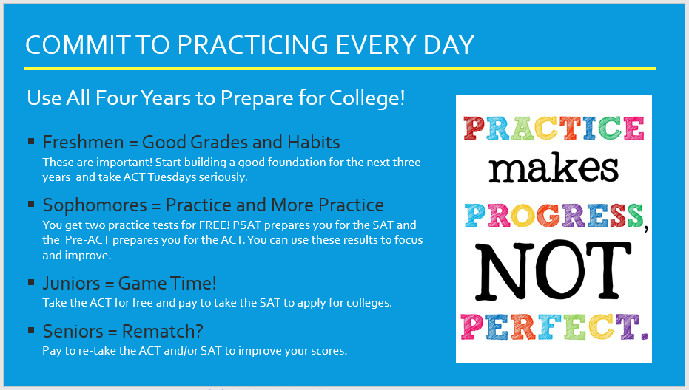

|  |  |  |
| --- | --- | --- |
|  |  |  |
| RESOURCE | **LINK** | **BEST FOR….** |
| Official ACT Site | <http://www.act.org/content/act/en/students-and-parents.html> | Test Prep, Resources for Students and Parents, Broken Down by Grade Level. |
| SuperTutorTV  (on YouTube) | <https://www.youtube.com/user/SuperTutorTV> | Secret TIP, TRICKS and HACKS Plus Practice Tests. |
| Crack Act | [https://www.crackact.com](https://www.crackact.com/) | Hundreds of Practice Tests Broken Down by Subject. |
| High School Test Prep | <https://www.highschooltestprep.com/act/> | Breaks Down Practice Tests by Easy, Medium, Difficult or Very Difficult. Push Yourself! |
| Kaplan Test Prep | [https://www.kaptest.com/act/free/act-free-events#live](https://www.kaptest.com/act/free/act-free-events) | Free Online Prep Events and Other Resources. |
| Study.com | [https://www.study.com](https://www.study.com/) | 440+ Video Lessons, Full-length Practice Tests, Flashcards and a Downloadable App. |
| Cool Math | <https://www.coolmath.com/reference/polygons-05-pentagons> | Brush Up on Polygons |
| Effortless Math | <https://www.effortlessmath.com/math-topics/act-math-formulas/> | Know Your Formulas! |